Runbook – OWL ESG

Welcome everyone to today’s Webinar entitled
Data in the Driver Seat: How Data Quality Can Make or Break ESG's Race into Mainstream Investment

ESG considerations are increasingly a part of our collective consciousness, investors included. Bad ESG data, a common problem in the investment world, can prevent investors from achieving financial or sustainability goals. Used appropriately, good ESG data is the foundation of both values based and value-based investment strategies that are no different than other metrics when evaluating investment decisions. Under the current model, ESG data available to investors is either low-quality, or requires significant investments of time and money. There are changes coming to ESG data collection and processing, and the market and the world stand to benefit.

In this webinar our speakers OWL ESG CEO, Ben Webster and Metafoura Founder Joseph Mezrich will discuss this important topic.

Panelist Bio points:

Ben Webster
- Ben Webster is the CEO and co-founder at OWL ESG, transforming how ESG data is gathered, analyzed, researched, and applied, by providing AI-powered software to completely revolutionize how professionals who need primary ESG data and analytics conduct business.
- He holds a Bachelors in Physics from the University of California, Los Angeles (UCLA), and has 18+ years of experience in the financial services industry across various areas including asset management, advisory, capital markets, hedge funds, private equity, and more, with significant expertise in exchange traded funds (ETFs), indexing, and ESG investing.
- He is a frequent panelist and presenter at industry conferences regarding the use of ESG data and metrics in the investment process, being a proud proponent of ESG investing’s application for making the world a better place for our children and future generations.
Joe Mezrich
- Joe Mezrich founded Metafoura LLC in July 2023, focused on quantitative investment research, after three decades as a sell-side quantitative investment strategist at Nomura, UBS, Morgan Stanley, and Salomon Brothers.
- Joe received the Ph.D. in Mathematical Psychology and MA in Statistics from the University of Michigan and received the EE and the SM degrees in Electrical Engineering from the Massachusetts Institute of Technology
- His work has been well covered in the media (Bloomberg, FT, Wall St Journal, etc.).

Timeline (60 minutes total):
- Housekeeping (2 mins)
- Context setting & introduction (3 mins)
- Main content (35 mins)
- Q&A (10 mins)
- Wrap up + Overview (5 mins)

Audience poll questions:
- In what way have you encountered ESG recently? (Slide 5)
  - Through products
  - Investments
  - Strategic decisions
  - Other
- How confident are you that your investments and portfolios are aligned with the ESG goals they claim to accomplish? (Slide 10)
  - Not at all confident
  - Somewhat confident
  - Moderately confident
  - Highly confident

Seed questions (in case audience participation is light):
- How much competition and innovation does the current stagnant ESG data market prevent?
- Does your application cover different reporting frameworks, and how will the upcoming SEC reporting requirements affect what you do?
- How long does it take to develop AI like this?
- As you have discussed ESG data problems with clients and prospects, can you quantify how much time per analyst this can save?
- How is the data from your application stored? Do clients get their own repositories, and is your original data included?
- Do you see any potential compliance implications with the current poor data quality problem? If so, what?

Webcast Main Content:

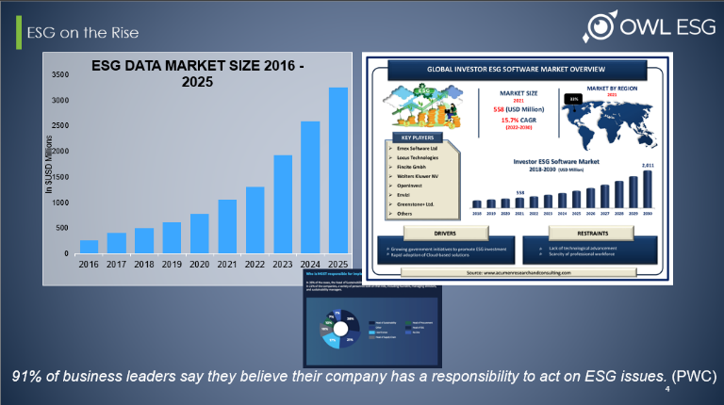
Slide 4:
ESG is on the rise. Importantly, it is growing dramatically in investor consciousness and influence on investment dollars, both because of market pressures and because of regulatory requirements.
Check out these facts:
- As of the end of 2021, over $36 Trillion was invested in ESG-related assets under management (AUM)
- Expected to pass $50 Trillion by 2025
- Retail wealth ESG AUM up 92 percent from 2015-2019 (S&P 500 up 40 percent)
- 95 percent of millennial investors interested in sustainable investments
- More than $70 Trillion in inheritance wealth transfer projected by 2035
- More than 550 ESG-dedicated investment vehicles (funds, ETFs, etc.) as of 2022
Corporate strategy is adjusting to this new paradigm, and investors expect portfolio and target companies to adopt ESG considerations and report on it.
This creates a need in the market, as investors want ESG data in the same way they have financials data.
POLL QUESTION ONE

Slide 6:
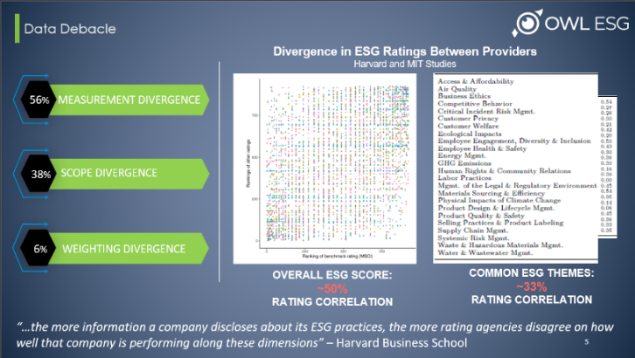
Unfortunately, while investors want corporate ESG data, the bulk of available ESG data products and metrics exists as scores produced by vendors where a number of subjective decisions drive the final score. Numerous studies have shown how dramatically these scores differ for the same company relying on the same disclosures.
We see problems in several crucial areas, including:
- 56% Measurement Divergence, which is when two firms use different indicators to measure the same attribute (i.e., employee turnover vs labor litigation)
- 38% Scope Divergence, which is when two firms use different attributes to form their rankings (i.e., include lobbying or ignore it)
- 6% weighting divergence, which is when two firms attach different levels of importance to the same attribute (i.e., how important is % women vs pay gap?)
- Among major ratings agencies, overall scores only correlate about half the time, and sub theme ratings correlate less than a third of the time
Investors who make ESG-related decisions based on these scores inherently adopt the priorities and inherit the divergence problems of the vendor that provided the score.

Slide 7:
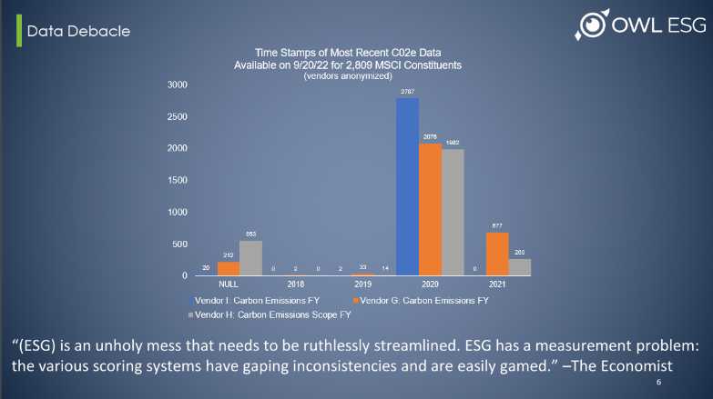
Many investors and firms adapted to the problems inherent with scoring by changing their models to directly collect and incorporate the underlying data that drives the scores, but that introduces an entire new set of problems. Investors can buy the data that is used to create scores from the vendors, but it is often unreliable itself, due to human error, time decay, and qualitative interpretations. And that’s best-case, as the collection of the data relies on corporate reporting that is non-standardized. Investors who purchase the data must dedicate often high-paid analysts to verifying the information. If they choose to collect data in house, it is even more resource intensive.
Even on the most prevalent ESG metric, carbon emissions, which is reported in a fairly standardized manner, we can see here on the slide how significantly different the data is from three different vendors.

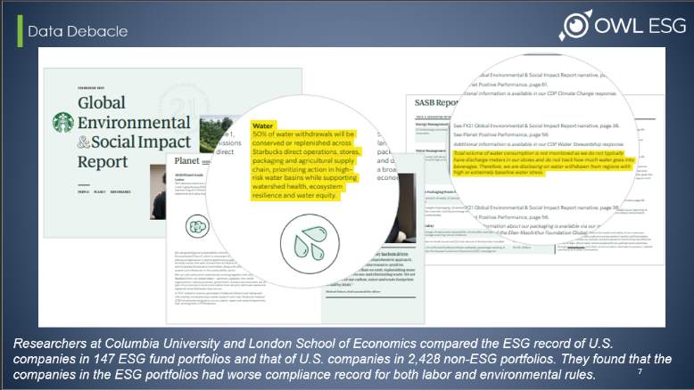
Slide 8:
This can have real-world, significant implications, where investors and firms might think they are putting money into a specific value of theirs, but the reality is far different. For example, at Starbucks, according to the most recent sustainability report, the company has committed to 50% of direct operations water withdrawals coming from recyclable or renewable sources by 2030. Of course, reading the fine print more than 100 pages later, we see that they do not consider retail stores part of direct operations. Not to come down on Starbucks, cause this sort of thing happens at many companies, but, in this case, if an investor holds SBX shares based on the belief that the company is making meaningful progress reducing impact on water availability, that investor will be making decisions without knowing the whole story. As things stand, this is ESG data. For some investors, it can mean investments not accomplishing what they intended. For others, there are far more substantial consequences.

Slide 9:
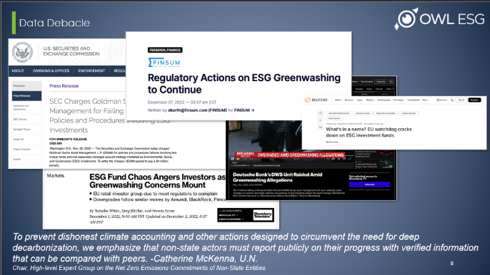
Obviously, making an investment based on an assumption that turns out to be incorrect is frustrating, and the margin for error is small in any investment situation. As bad as misguided investments can be, ESG investing is under such scrutiny that there is potential for significant reputational harm, and more, if investors fail to support the values which they advertised. With greater frequency, investment firms and other vehicles are facing accusations of “greenwashing,” where they have claimed to be dedicated to investing in companies that meet certain definitions of “sustainable” but, in fact, do not meet those specifications. Beyond reputational harm, fines and penalties can be huge.
Just last month, the SEC fined Deutsche Bank-controlled investment firm DWS $25 million for greenwashing, and BNY Mellon $1.5 million in May. They fined Goldman Sachs $4 million late last year for “policies and procedures failures involving two mutual funds and one separately managed account strategy marketed as Environmental, Social, and Governance (ESG) investments.” Regulators in the US and globally are ramping up enforcement actions around greenwashing.
As the ESG market grows, greenwashing and failed sustainable investments will occur with increasing frequency if we continue to rely on the current system. Deficiencies in ESG data is the worst kept secret in the market, but adherence to current solutions guarantees that the problem will only be exacerbated as the requirements get bigger. And, as we established at the beginning of this discussion, the ESG data market is exploding.

POLL QUESTION 2

Slide 11:
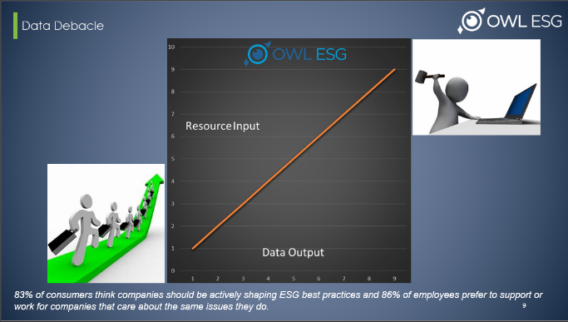
So why are the issues so bad? Obviously, the root cause of the problem is the human-collection model of data gathering. One person scans a corporate issuer filing or publication and either types in or copy / pastes a data point, and another person verifies it. That is generally what constitutes operations and QA. Mistakes are prevalent.
Further, when companies report critical information on a relatively frequent basis, like quarterly, data vendors simply do not have the human capital to capture those updates, and so time decay quickly becomes a problem.
Because data vendors sell bulk data with a preset selection of data points, there is extreme inefficiency.
In fact, some of these statistics are staggering:
- Most companies don’t use 99% of collected data.
- Only 1% of research reports generated are ever read.
- The average research analyst spends 2/3 of his/her time collecting unstructured data and trying to determine if that data is material.
- The average salesperson spends a majority of his/her time sifting through that data for nuggets to convince prospects to become clients
It becomes difficult to scale output without a linear scaling of inputs because data collection is so resource intensive. In other words, for each resource brought in, data output increases by a factor of one, there are no economies of scale and there is no operational efficiency. There is only a perpetual need to hire more people or use resources from elsewhere to meet increasing demand. Meanwhile, inaccuracy and stale data remain firmly embedded problems.

Slide 12:
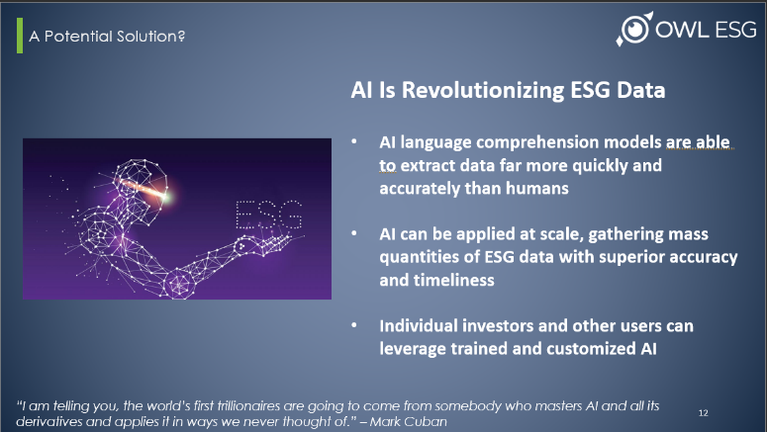
There is good news! As we race into the age of artificial intelligence at the speed of technology, solutions are at hand. Investors, corporations, watchdogs, NGOs, and especially data providers are making AI a part of their ESG strategies and operations with increasing frequency, and the results are beyond promising. AI, properly harnessed, can produce results in matters of seconds and minutes, not hours and days, and with near zero error rates. It can instantly create comprehensive analytics and reporting, conduct trend research, and provide feedback, freeing up valuable human resources to confidently make big decisions about things like strategy or portfolio selection.
New and advancing technologies and algorithms are already revolutionizing trading strategies. Analytics are exceedingly complex, and new information is available instantly. To address the ESG data problem, AI language comprehension models are able to extract data far more quickly and accurately than humans, saving cost on low-value data collection and allowing high-end talent to focus on more strategic work. This AI can be applied at scale, gathering mass quantities of ESG data with superior accuracy and timeliness. And it can be applied for specific needs, where individual investors and other users can leverage trained and customized AI to scan new filings and other ESG documents in real-time, which feeds the collected data into custom libraries, repositories, and databases, where it is then integrated into existing proprietary analytics and software.
And, as much as bad data presents a whole host of problems, good data opens up a whole new set of possibilities and upsides.

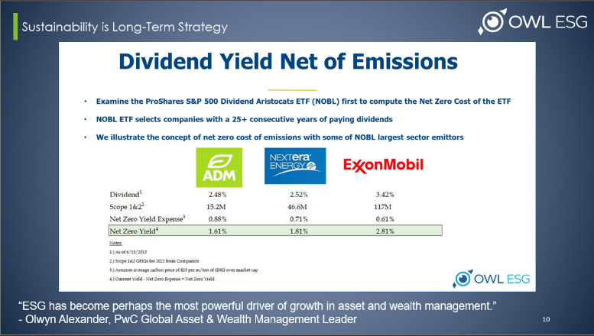
Slide 13:
Leveraging AI, with reliable data, the benefits of confidently investing in ESG are significant - environmentally, socially, and financially. In fact, the difference between reliably bringing ESG considerations into mainstream investing considerations, and accepting that ESG will languish in a niche, reserved for investors who are primarily motivated by ESG-related values is simply a matter of data accuracy and timeliness.
For example:
- Technology solutions built around carbon pricing and carbon offset verification create a robust opportunity for investors to put their money into companies that would traditionally not be considered green.
- If carbon can be priced reliably, that cost can be distributed among all shareholders, in a “carbon-adjusted yield,” not much different from any other risk-adjusted yield.
- As we see in the slide, even emissions-intensive companies like Exxon can offset all their Scope 1 and 2 emissions and still pay solid, consistent dividends.
- This incentivizes companies, like Exxon, to proactively address GHG emissions, instead of fighting against mitigation.
- Long-term value investors, who seek blue-chip companies with reliable dividends can now hold those stocks in their portfolios while also supporting sustainable business practices. And sustainability focused investors can build long-term value portfolios.
- However, for this to work at scale, good data is a necessity.
Investment strategies built around blue-chip stocks with strong, regular dividends have traditionally not meshed well with investments dedicated to sustainability-focused holdings. Good data can completely change that, which also leads to investors improving engagement strategies with potential target companies. The benefits compound.

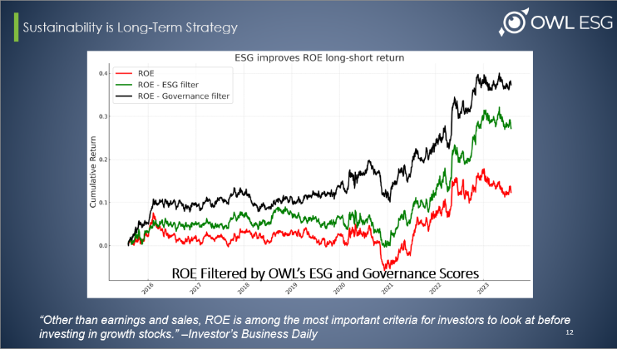
Slide 14:
Including ESG factors as a filter in investment decisions can improve a number of financial metrics. Return on Equity, for example, is an important metric for investor strategic decisions, and one that is popular because of its direct connection to financial returns on money invested in particular stocks.
Here we can see that the universe of the top 1000 stocks by market cap follow the same basic trendline over an eight-year period from 2015 to 2023. Applying filters to this universe for ESG and Governance factors creates separate and distinct lines that follow roughly the same trends, but with significantly higher respective returns on equity.
Note: Monthly rebalanced long-short ROE, Filtered by ESG and filtered by Governance, universe of top 1000 stocks by market cap. Neutralized by Industry and factors: credit, growth, liquidity, momentum, size, value, volatility. Plot is from July 30, 2015 through July 30, 2023.

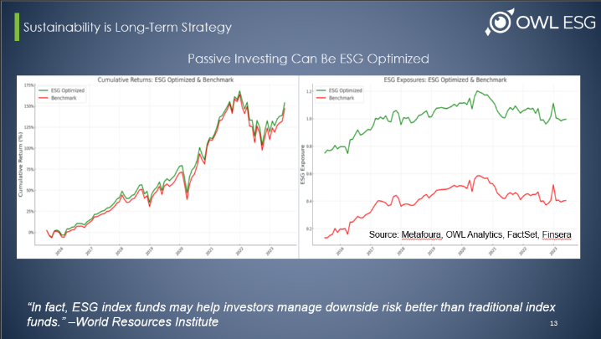
Slide 15:
ESG factors can be incorporated into a passive strategy to improve returns at a significant rate. There are many possible reasons for this, but companies that incorporate ESG factors into their strategic decisions are likely to be more responsive to other signals as well. Further, they have an advantage attracting direct capital, customers, and investment dollars. They avoid potential regulatory scrutiny. And they are often simply more nimble and flexible, better suited to adapting to changing market conditions, of which the rise of ESG is simply the latest evolution. Bad data prevents investors from reliably leveraging these advantages, and the current system prevents investors from building comprehensive analytics to take full advantage of these opportunities, as valuable resources are squandered in low-value work.
Left panel shows cumulative returns; right panel shows ESG exposures. Benchmark (red line) is the top 500 US stocks by market cap. ESG Optimized (green line) is a monthly rebalanced, long-only portfolio optimized so that the stocks have substantially higher ESG exposure than the benchmark while minimizing tracking error to the benchmark. Period is from June 2015 through June 2023.

Slide 16:
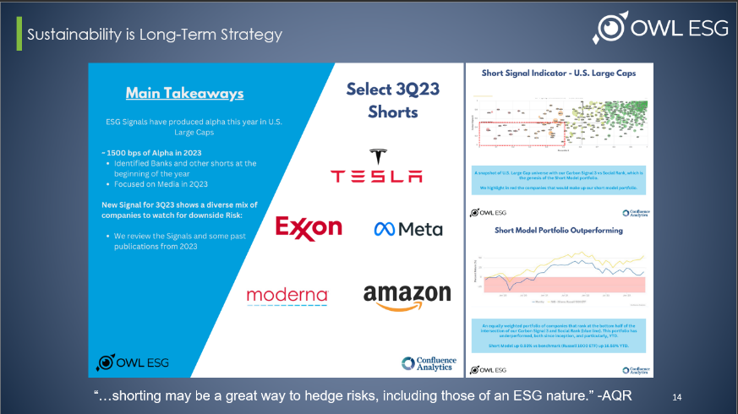
With reliable ESG data, these metrics can even be used to build out a short strategy. For example, a social signal combined with an emissions signal, in this case built out by Confluence Analytics, provides a powerful indication of stocks to short. This model portfolio, based on this signal, would have provided a return of 1500% percent year to date. Again, this isn’t illogical; companies that fail to keep employees happy are more likely to see decreased productivity. And companies that do not evolve with market conditions will suffer.
Evaluating these corporate strategies effectively within a portfolio, index, or broader investment target requires reliable data. Bad ESG data will ensure that none of the benefits of ESG investing manifest. Good data can push returns above and beyond, catapulting ESG into the mainstream investing world, and driving value and values, meaning people make money, and the world sees positive change.

Slide 17:
Q&A (seed questions on the first page)

Slide 18:
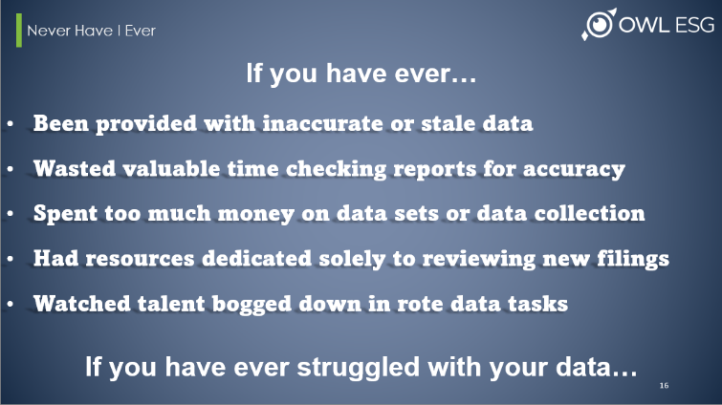
We talked today about the problems with ESG data in the market, some potential solutions, and why those solutions matter. But these aren’t just statistics, these are pervasive problems that affect all of us. Ask yourself, have you ever been had to work with inaccurate or stale data you purchased? Have you ever wasted valuable time checking reports or analyses for accuracy because of data concerns? Have you or your company ever spent too much money purchasing data sets from third parties or hiring resources for manual data collection and review? Have you ever had to hire resources specifically dedicated to identifying, reviewing, and pulling updated data from new corporate filings like proxies and sustainability reports? Have you encountered bumps in your work life, or had to watch other talented employees, bogged down in rote tasks related to data collection, verification, analysis, and QA? How much time and money do you think gets wasted on bad data and inefficient collection processes every year? How much of an advantage would it be to overcome these hurdles?

Slide 19:
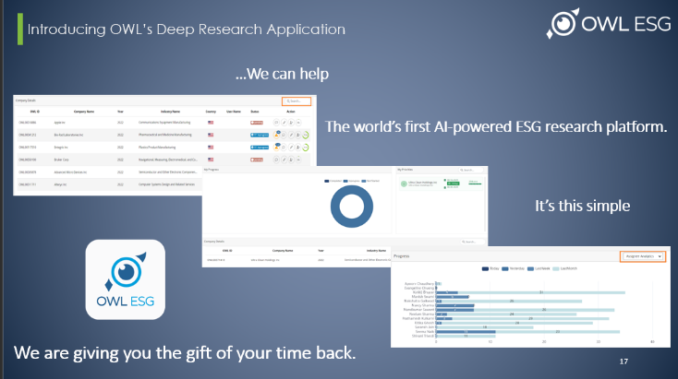
Some of the issues with data collection are so pervasive and ingrained that people don’t even consider them problems anymore, they are just cost-of-business aspects of daily operations.
This is where OWL comes in. With our advanced language model AI, ESG data problems disappear. We have built out a language model AI trained with umans to avoid some of the errors we see in generative AI models. Our Deep Research App leverages our AI, not only trained to pull the data points we collect currently, but customizable to collect new data points to fit your needs. It can scan freshly published 200 page documents in about the time it takes to grab a cup of coffee, and its error rate is exceedinly small, and will continue to get better the more its used. Finally, you can take this data and integrate it as needed into your own analytics, freeing up valuable resources to do valuable work and exponentially increasing the productivity of each employee. We turn an analyst into a team, and a team into an army, giving you the gift of you time back.

Slide 20 (if there is time):
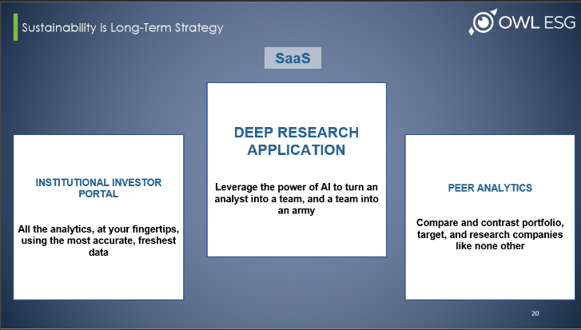
And we are building out a software suite, starting with our Deep Research Application, and all started on the foundation of the best ESG data available, we are truly dedicated to transforming how ESG data is gathered, analyzed, researched, and applied, and, in doing so, revolutionizing ESG investing.

